NBA Players Draft Predictor using NETICA

Abstract:

Before the start of every NBA season, NBA drafts will take place and all the teams needs to be prepared to pick new players and also to trade in weak players to stronger players. The draft chances are all probabilities calculated using all the features of the player.

During the drafts, the two main picks are called the draft and the trade. Trade is when a current player of the team is replaced with a better player from another team. Draft is when a new player is picked straight out of college. The features for these two kinds of players each have different importance values. The final stats of the player depend on each of these features. Thus, we use Bayesian network to reduce this complex problem into a simple one.

The Bayesian Network has nodes and connectors that form the network. For each node, the probability values are entered and based on these values, the probability of a player getting drafted is calculated. The decision node is added to predict the contract status and the utility node is added to predict the chances of the player playing for that particular NBA season.

Features:

There are totally 18 nodes in this network that will help calculate the probability of the NBA player getting drafted. The first set of features are the physical and the fitness features. They include the age, height and weight of the player. The probability of the player increases if the player has experience and if he is tall.

The next set of features are the performance factor. This includes the number of seasons played, number of MVP awards won and also the number of championships won. The number of seasons played, increases the chances of getting drafted.

The health of the player is evaluated by considering the injuries. The more serious the injury, lesser is the probability. The teams would not prefer the players who is injury prone.

One of the main skills of the player is his ability to play any position. There are totally five positions namely point guard, shooting guard, center, small forward and power forward.

After predicting the chances of the player getting picked, the decision node tells us the contract status and finally the utility node gives us the probability of the player playing for the picked NBA team.

Instructions to run:

* Copy the .neta file in any location and open it in Netica
* Compile the network
* Change the input values by clicking on the root nodes to see the changes flow through the network
* The final probability values of the player getting drafted is displayed in the stats node

Bayesian Network:

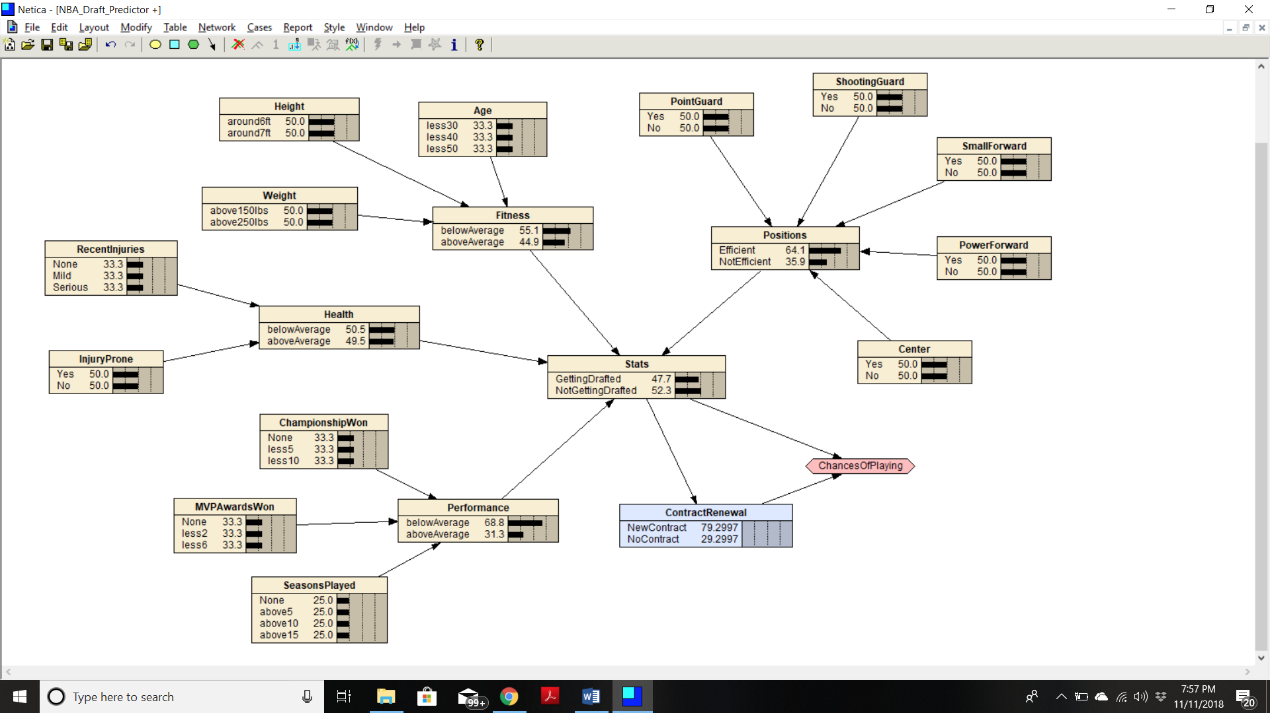

Figure 1

Test Case:

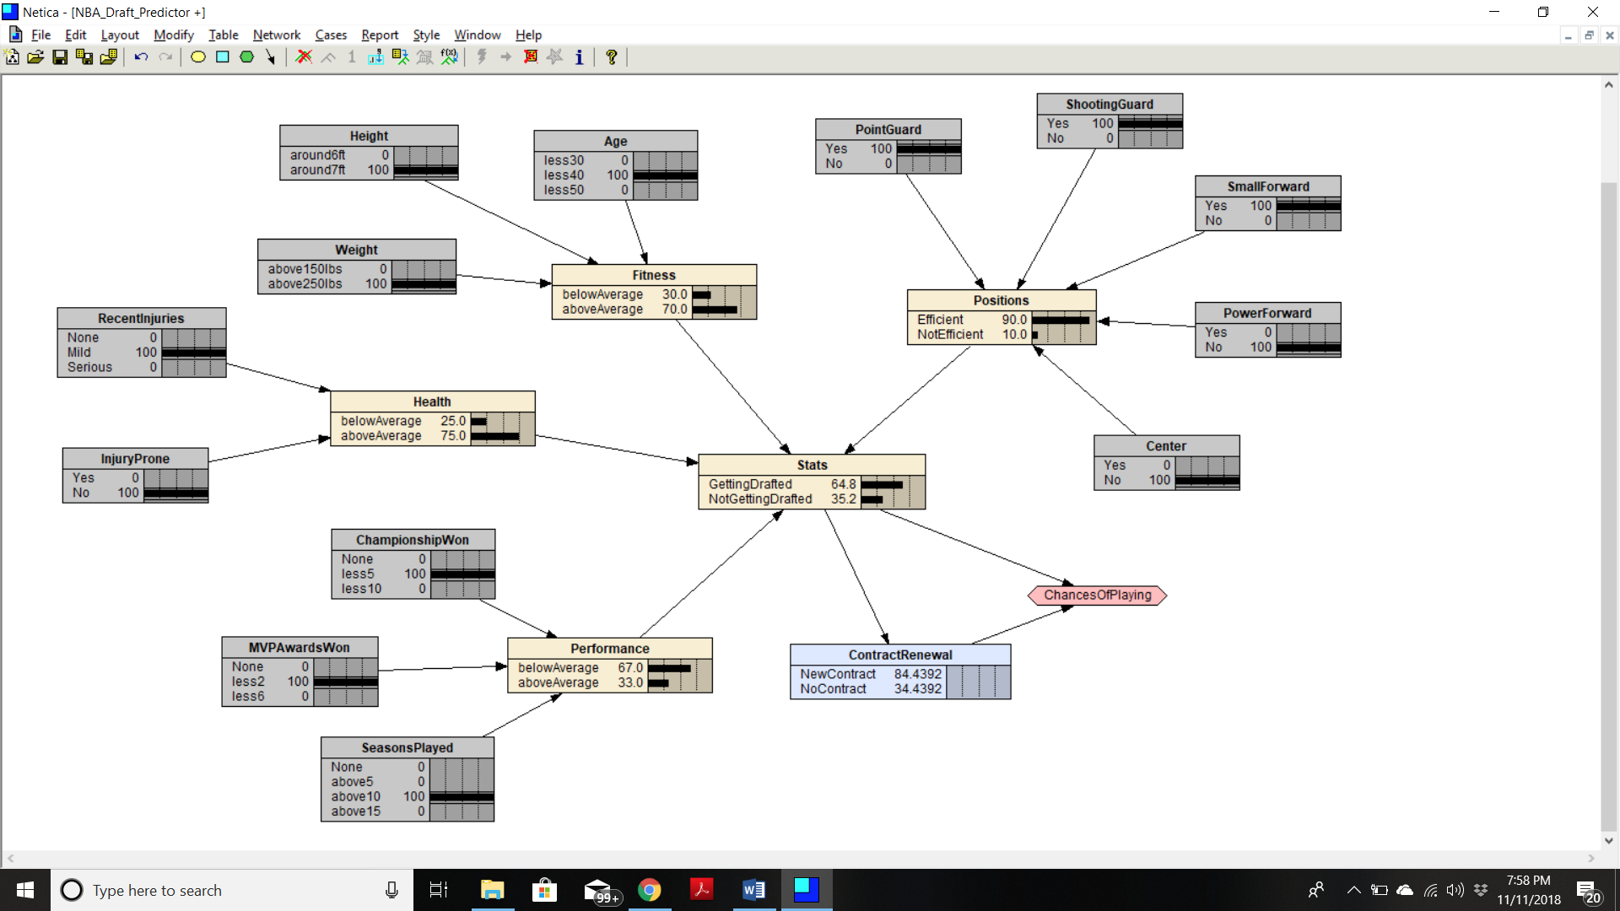

Figure 2